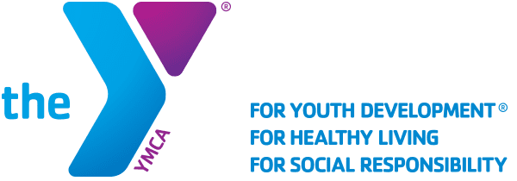

Corona-Norco Family YMCA Youth and government
Contact Ryan Serna: Serna@ymcacornor.org

What is Youth and Government
- A teen leadership program focused on a model government and court system
- An amazing program to develop leadership skills, public speaking, and confidence
- A program that looks great on both college applications and job applications
Important Dates
- First Meeting: September 4th 6:00PM
- Weekly Meetings every Monday at 6:00PM
- First Conference: November 9th-12th
- Final Conference: February 16th-19th
Who is it for
- High school students
- Currently in grades 9-12
- Those who want to develop leadership skills
- Those who love to debate
What does a meeting look like
- A typical meeting will start with an invocation from the president
- We do an icebreaker type game
- Then we will transition into a debate on a topic chosen by the delegates
- Then we talk about program areas and any major program wide news
- Then we discuss current events or anything the kids want to share
- We have a delegation activity
What does a conference look like
- We will bus to the conferences (We may fly depending on number of delegates and cost)
- We will be staying at Camp Roberts for the first conference in the residence halls
- We will be staying at a hotel in Sacramento for the duration of the conference
- Both conferences are 3 nights overnight
- At the conferences, the delegates will get to put their hard work to the test
- They will work on and present bills and debate court cases
- Go to trainings about their program areas
- Have joint sessions where all 3000+ kids are together in a hall
- Have elections where they vote on the future leaders of the program
Sacramento Attire
- When we go to the final conference in Sacramento, everyone is required to dress up
- That means slacks, a bottom layer like a button up, and an over layer like a jacket
- Girls (or boys) may wear a dress, which counts as the bottom layer and the bottoms, but you are required to wear a over layer as well
Fees
- Program fee to YMCA of LA - $750
- Transportation Fees on top
- We are asking looking at charging $500 per student with a $250 deposit and hoping to be able to fundraise to cover the rest, with financial assistance available.

