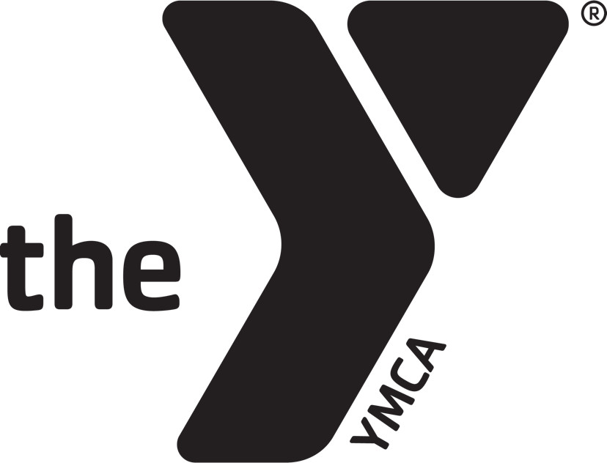

Youth Basketball Program Handbook

Program Director Corona-Norco Family YMCA
Jonathan D’Angiolillo 1331 River Rd
jdangiolillo@ymcacornor.org Corona, CA 92880

A coach is someone who can give correction without causing resentment.
A good coach can change a game. A great coach can change a life.
John Wooden
They call it coaching, but it is teaching. You do not just tell them…you show them the reasons.
Vince Lombardi
We don’t want to tell our dreams,
We want to show them
Cristiano Ronaldo
The most important thing is to try and inspire people, so that they can be great in whatever they want to do.
Kobe Bryant
Dear Parents and Coaches,

Thank you for choosing the Corona-Norco Family YMCA Youth Soccer Program. We’re looking forward to a fun season and we hope your child has a great time.

Our goal is for each child to learn the fundamentals of the game, develop self-esteem, and see the value of teamwork and good sportsmanship…all while having fun! This is accomplished by emphasizing the YMCA Core Values of Caring, Honesty, Respect, and Responsibility. Each Coach and Parent is asked to sign a Code of Conduct prior to the season. Please use this handbook as a tool to help make your season the best possible experience for you and your athlete(s), and do not hesitate to ask YMCA staff any questions you may have.

The Corona-Norco Family YMCA recognizes that volunteers are an integral part of any youth sports program, and we wish to recognize our coaches for their hard work and dedication. We are grateful that they give their time to mentor youth through soccer.

We look forward to a great soccer season! Thank you again for your time and commitment.

Sincerely,

Jonathan D’Angiolillo
Program Director

ITTY BITTY | AGES 3-5
ROOKIES | AGES 6-8
CHAMPIONS | AGES 9-11
RULES, POLICIES, PROCEDURES AND ELIGIBILITY
AGE DIVISIONS

The Y

At the Y, strengthening community is our cause. We believe that lasting personal and social change can only come about when we all work together to invest in our kids, our health and our neighbors. That is why we focus our work in three areas:

-YOUTH DEVELOPMENT: Nurturing the potential of every child and teen
-HEALTHY LIVING: Improving the health and well-being of families in our community
-SOCIAL RESPONSIBILITY: Giving back and providing support to our neighbors

UNIFORMS

1.All participants must wear basketball shoes for all games and practices.
2. Participants are NOT allowed to wear earrings, watches or other objects that might constitute a hazard during games and practices.
3.The jersey is reversable, with the home team wearing blue and the away team wearing white.

Rules

- GAME TIME: There will be four (4) – eight (8) minute running clock quarters for the Itty Bitty and Rookies division, with a two (2) minute halftime. Game time will be four (4) – ten (10) minute running clock quarters for the Champions division. IN THE CHAMPIONS DIVISION: If the score in the second half is within ten (10) points or less in the final two (2) minutes, then the clock will stop on every whistle. THE CLOCK WILL STOP FOR ALL INJURIES
- SUBSTITUTIONS: Will be mandatory at EVERY (4) – four minute mark for Itty Bitty and Rookies division. IN THE CHAMPIONS DIVISION every (5) – five minute mark per quarter. Substitutions will be made at the discretion of the coach. The referee may disqualify a player if he/she feels that player is becoming too physical. This rule will not apply for injuries, illnesses, or if there are not enough players to sub.
- PLAYERS: A team must have five (4) players to start the game. A team can finish with as few as four (3) players if they lose players due to disqualifications, injury or some other unforeseen circumstance.
- TIMEOUTS: Each team receives two (2) timeouts per halves. Unused timeouts do not carry over into the second half or overtime. Each team will receive one (1) timeout for overtime.
- OVERTIME (OT): There is no overtime in the Itty Bitty or Rookies division. If the score is tied at the end of regulation, the game will result in a tie. IN CHAMPIONS DIVISION: There will be one (1) 5-minute running clock for overtime. If the score is tied after overtime expires, then the match will end in a tie.
- GOOD SPORTSMANSHIP: All players, coaches and parents are required to be respectful and deliver on good sportsmanship. Upon poor sportsmanship, the coach, player or parent will be disqualified from the match and asked to leave the grounds by the Program Director.

Policies

COACH GUIDELINES AND EXPECTATIONS
Coaches are expected to show up to all practices and games. Coaches must promote good sportsmanship, and Y values; caring, respect, responsibility, and honesty during all interactions with the players, referees, parents and staff. YOU are the reason why the program is successful.

COACHES BACKGROUND CHECK
All coaches must complete a volunteer packet (background check) and an online child abuse training before the season. Volunteer packets and online training must be completed prior to the start of the season.

CONTACTING YOUR TEAM
All coaches are responsible for contacting their team throughout the season. Coaches will be given a parent and player roster with contact information by the program director.

Referees

Referees facilitate fair play during games by giving each team equal opportunities within the limits of the rules of the game. Please cooperate with them in creating and maintaining an environment in which players have fun and learn good sportsmanship. Referees may stop play on occasion for instructional purposes and give allowance for violations based on the ability of the group.

PARENT CODE OF CONDUCT

Please arrive on time for all practices and games. Remain in the spectator area during practices and games. Keep comments positive to players, parents, officials and coaches. Cheer for all players and encourage good sportsmanship. Show interest, enthusiasm, and support for your child. YMCA Sports Staff will supervise all practices and games to provide equipment, assist coaches, provide first aid, and answer any sports questions. If any issues may arise, please contact the Sports Staff or Program Director at jdangiolillo@ymcacornor.org. All parents are required to sign a Spectators Code of Conduct before the start of the season.

REFUND POLICY

After the first week of games, we will not offer refunds for the program. Under extreme circumstances, if a refund request is made, the program director has the discretion to be able to offer a system credit. If a refund is requested prior to the first game, a 20% administrative fee will be applied to the refund.

MINIMUM PARTICIPATION POLICY

We will not start a league if we do not have a minimum of 8 players per team and a minimum of two teams in any age group.
WEATHER POLICY

Our sports are outdoors, and we cannot control the weather. Due to our seasons being on a fixed schedule, we apologize, but cannot offer an extension of the season due to weather cancellations. We will make our best effort to reschedule to a different day that week or schedule a double header to make up for the weather cancellation.
Character Building

CARING | To care for others and be sensitive to the well-being of others in our program
HONESTY | To have integrity. YOU take responsibility for your own actions
RESPECT | To value the worth of each person in our program
RESPONIBILITY | To be accountable for YOUR behavior and obligations

Procedures
YMCA YOUTH SPORTS PHILOSOPHY

The philosophy of YMCA Youth Sports embodies the mission of the YMCA and provides the framework and foundation on which The Y can build their sports programs. What we in the YMCA want youth sports to be is stated in these SEVEN PILLARS OF YMCA YOUTH SPORTS:
- EVERYONE PLAYS. We do not use tryouts to select the best players, nor do we cut kids from YMCA Youth Sports. Everyone who registers is assigned to a team. Due to the high volume of participants, there will be no special requests for team placements.
- SAFETY FIRST. Although some children may get hurt playing sports, we do all we can to prevent injuries. We've modified each sport to make it safer and more enjoyable to play. We ask YOU to make sure the equipment and facilities are safe, and the skills being taught are fun for beginners.
- FAIR PLAY. Fair play is about more than playing by the rules. It's about YOU and YOUR players showing respect for all who are involved in YMCA Youth Sports. It's about you being a role model of good sportsmanship and guiding your players to do the same. Remember, we're interested in developing children's character through our sports programs.
- POSITIVE COMPETITION. We believe competition is a positive process when the pursuit of victory is kept in the right perspective. The "right perspective" means adults make decisions that put the best interests of the children above winning the contest. Learning to compete is important for children, and learning to cooperate in a competitive world is an essential lesson of life. These are the lessons we want to teach through our youth sports programs.
- FAMILY INVOLVEMENT. YMCA Sports encourages parents to be involved with their child's participation in our sports programs. In addition to parents being helpful as volunteer coaches, officials and timekeepers, we encourage them to be at practices and games to support their child/ren. To help parents get involved appropriately, YMCA Youth Sports offers a mandatory coach/parent orientation before the season begins.
- SPORTS FOR ALL. YMCA Youth Sports is an inclusive program. That means that children who differ in various skill sets are to be included rather than excluded. We offer sports programs for children who differ in physical abilities by matching them with children of similar abilities and modifying their sport. We offer programs to all children regardless of race, gender, religion or ability. We ask our coaches and staff to support and appreciate the diversity of children in our society and to encourage the children and their parents to do the same.
- SPORTS FOR FUN. Sports are naturally fun for most children. They love the challenge of mastering the skills of the game, playing with their friends, and of competing with their peers. Sometimes when adults become involved in children's sports, they over-organize and dominate the activity to the point of spoiling children's enjoyment of the sport. If we take the fun out of sports, we are in danger of our children taking themselves out of sports. Remember, that these sports are for the kids; let them have fun.

THE Y: SPECTATOR’S CODE OF CONDUCT

1. Remember participants play organized sports for recreation and enjoyment
2. Refrain from using profane language
3. Do not harass any staff, players, parents, coaches, officials, and/ or spectators
4. Show respect for all opponents and applaud efforts for all
5. Never ridicule or scold participants for making a mistake during a game or practice
6. Violence in any form will not be tolerated
7. Respect for officials’ decisions
8. Encourage players to follow rules

WE EXPECT ALL PERSONS USING THESE FACILITIES TO ACT IN A MANNER CONSISTENT WITH THE FOUR CORE VALUES OF THE YMCA: CARING, HONESTY, RESPECT, AND RESPONSIBILITY. THE ABOVE RULES LISTED ARE MEANT TO BE FOLLOWED AT ALL TIMES. FAILURE TO FOLLOW THE ABOVE RULES WILL RESULT IN DISQUALFICATION FROM OUR SPORTS PROGRAM.

OUR Y PLEDGE
I WILL CARE FOR OTHERS
I WILL BE HONEST TO THE SPORT AND MY TEAM
I WILL RESPECT MY COACH
I WILL TAKE RESPONSIBILITY FOR MY OWN ACTIONS

CEO MESSAGE

Welcome to the Corona-Norco Family YMCA! It is our honor to have you join the YMCA family. We are committed to ensuring quality programming incorporated around our 4 core values: honesty, caring, responsibility and respect. Together we build confidence, sportsmanship, and character in our local youth.

Thank you for supporting our YMCA as we continue to invest in our community! At the Y, everyone belongs.

Warmly,

Audrie Echnoz

HAVE A GREAT SEASON!

