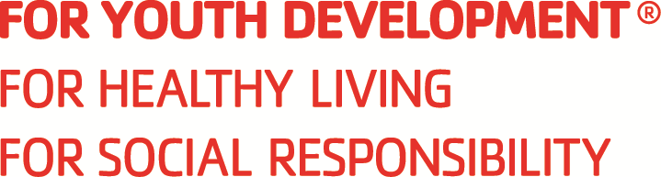

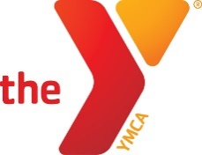

CORONA-NORCO FAMILY YMCA
Job Description & Performance Standards

Position: YMCA Swim Instructor
Reports To: Program Director

Duties and Responsibilities
- Instructs swimming lessons in accordance with YMCA guidelines, having prepared lesson plans accordingly.
- Builds effective, authentic relationships with students and parents; helps them connect with each other and the YMCA. Encourages parent involvement and identifies potential volunteers.
- Conveys information on aquatics programs and schedules and as appropriate refers students and parents to other programs.
- Maintains records as required (i.e. attendance, progress reports, etc.).
- Knows and reviews all emergency procedures and responds to emergency situations immediately in accordance with YMCA policies, procedures, and the “safe-in-six” model; completes related reports as required
- Knows, understands, and consistently applies safety rules, policies, and guidelines for the pool and aquatic area
- Performs equipment checks and ensures appropriate equipment is available as needed
- Checks the pool for hazardous conditions when arriving
- Identifies and celebrates the successes of members and program participants
- Attends and participates in all staff meetings and in-service training
- Performs other duties as assigned

Mission Advancement
- Models and teaches the Ys values
- Ensures a high level of service with a commitment to changing lives
- Provides volunteers with orientation, training, development, and recognition
- Cultivates relationships to support fund-raising

Collaboration
- Champions inclusion activities, strategies, and initiatives
- Builds relationships to create small communities
- Empathetically listens and communicates for understanding when negotiating and dealing with conflict
- Effectively tailors communications to the appropriate audience
- Provides students with feedback, coaching, guidance and support

Requirements / Skills / Qualifications
- Certifications: Current YMCA Swim Instructor Certification required, must be obtained within 14-days of hire
- Current YMCA Lifeguard or equivalent (Red Cross Lifeguard) preferred, training may be provided
- Ability to maintain certification-level physical and mental readiness
- Must demonstrate lifeguard skills in accordance with YMCA standards if certified as Lifeguard
- Background Check

WORK ENVIRONMENT & PHYSICAL DEMANDS:
- The physical demands described here are representative of those that must be met by an employee to successfully perform the essential functions of this job. Reasonable accommodations may be made to enable individuals with disabilities to perform the essential functions
- Physically perform all skills required of a swim instructor
  - Ability to swim 25 yards of at least four assigned swim strokes
  - Ability to tread water for at least 2 minutes without stopping
  - Assist participants into and out of the pool at the side
  - Hold, lift, and move participants in the water during class as required by YMCA Swim Lesson Certification training
- Hear noises and distress signals in the aquatic environment, including in the water and anywhere around the zone of responsibility
- Remain alert with no lapses of consciousness
- See and observe all sections of an assigned zone or area of responsibility

