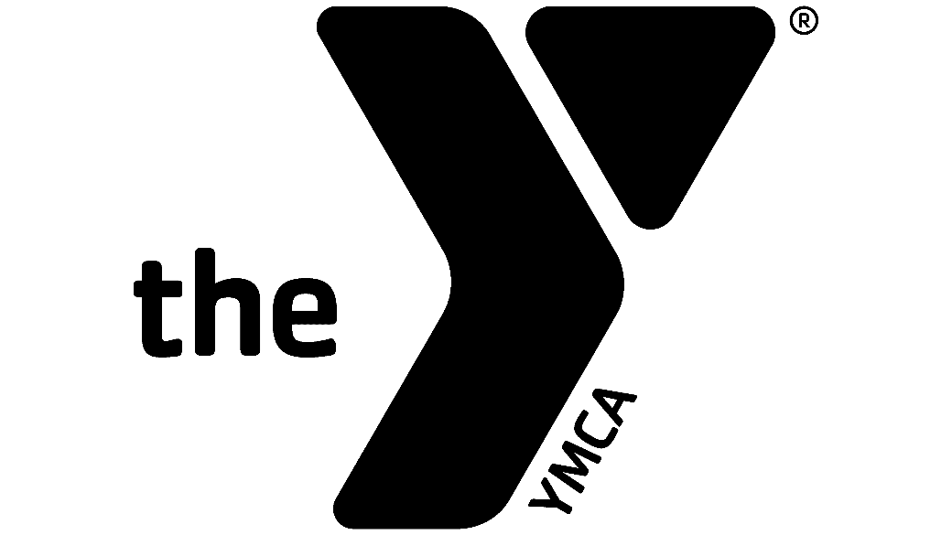
FIND
YOUR
FUN

SUMMER DAY CAMP
Corona-Norco Family YMCA
Parent Handbook

Rev. 4/6
Corona-Norco Family YMCA
1331 River Rd.
Corona, CA 92880
P 951.736.9622 | www.ymcacornor.org

Dear YMCA Family,

At the Y, we believe that all kids deserve the opportunity to discover who they are and what they can achieve. Through the Y, millions of youth today are cultivating the values, skills, and relationships that lead to positive behaviors, better health, and educational achievement.

The Y works diligently to make the support and opportunities that empower people and communities to learn, grow, and thrive accessible to all. With a focus on youth development, healthy living and social responsibility, the Y nurtures the potential of every youth and teen, improves the nation’s health and well-being, and provides opportunities to give back and support our neighbors.

This handbook was created to describe our program and goals, explain policies, and detail operating procedures. We will review this handbook during the enrollment process, but please keep it in your personal files and refer to it whenever you have questions about our program.

The Y is a cause driven organization; our core values help guide our programs.

YMCA Mission Statement
To put Judeo-Christian principles into practice through programs that build healthy spirit, mind and body for all.

YMCA Character Development

Caring
Show a sincere concern for others.

Honesty
Be truthful in what you say and do.

Respect
Follow the golden rule.

Responsibility
Be accountable for your promises and actions.

YMCA Summer Day Camp Goals
The Y’s Day Camp Program provides a fun and memorable experience for every child and teen, as well as fosters a nurturing environment and safe community for young people to explore the outdoors, build self-esteem, develop interpersonal skills, and build lasting friendships.

YMCA Summer Day Camp Staff
At the YMCA, we hire qualified and enthusiastic staff members who are excited to work with children. Most of our staff are year-round YMCA employees who work at our before & after school sites. We require that all staff be at least 18 years of age, are certified in CPR & First Aid, are tested for substance abuse and fingerprinted. We provide our staff with a minimum of 24 hours of camp training which includes but is not limited to; health and safety, risk management, supervision, behavior management and discipline, camper ratios, and child abuse prevention.

If you have any further questions, please feel free to speak to the Corona-Norco Family YMCA at 951.736.9622.

Program Director, Ryan Serna: 951.432.4966

Registration Information
All paperwork must be completed the Friday before the week of camp by Noon for new registrations. For the safety of your child, we cannot accept same-day starts when you register your child. Any registrations occurring the week of care need a full business day to be processed.

FEES

Deposit
A deposit of $50.00 per child is due at the time of registration. This holds your child’s spot for the duration of Day Camp and is non-refundable if the child does not end up attending the program. If a child drops from the program for any reason without a 72-hour notice, the deposit will be forfeited and have to be repaid before the child can return.
All deposits are non-refundable but will be applied toward the final week of care for those who have complied with our policies and procedures throughout the program.

Late Payments
A 10% late payment fee will apply to any payments that are made past the date the payment is due. If payment is not received in the allotted grace period, the participant will be dropped from the program and the parent will need to re-register their child for the program and repay deposit.

Late Pick-ups
If the participant is picked up after 6:00 pm the parent will be charged $1.00 per minute until the child is picked up.

Payment Information
Weekly payments are due the Thursday prior to the start of care. If the payment is not received by 6:00 pm on Thursday, a Late Payment Fee of 10% will be charged to your account. If the payment is not received by Friday at 12:00 pm, your child will be dropped from the program and the deposit of $25.00 will have to be repaid before your child can return to the program.

There is no credit for absences or vacations. The parent’s payment is required regardless whether your child is in attendance or not and refunds will not be issued for non-attendance. If a child is suspended and/or terminated from the program for un-excused behavior or defiance, no refunds will be issued.

Payments can be made in the form of credit card Monday through Friday, 9:00am-6:00pm at the Front Desk in person or over the phone.

Financial Assistance
Financial assistance for our Day Camp programs is available to those who qualify. Applications are available for pick-up at our branch office and can also be downloaded online. The Corona-Norco Family YMCA requires proof of household income with all applications and has the right to modify assistance depending on funding availability. In addition, please be sure to get your application in early as it may take up to two weeks to process. For more information, please contact us at 951.736.9622.

DAYS OF OPERATION
The Corona-Norco Family YMCA Day Camp Program and the Corona-Norco Family YMCA Offices are closed the following days:
- Memorial Day
- Fourth of July
- Labor Day
- Thanksgiving and the day after
- Christmas Eve and Day
- New Year’s Day

CAMP HOURS
Summer Day Camp operates from 7:30 a.m.-6:00 p.m. Program hours are between 9:00 am and 4:00 pm, and ALL CHILDREN MUST BE IN ATTENDANCE DURING PROGRAM HOURS. Children MUST be dropped off NO LATER than 9:00 am daily. For safety reasons, there will be no admittance to camp after 9:00 am. If you need to arrive late to Camp, please provide the Day Camp Program Director a 24-hour notice, and when applicable we can accommodate your request. The YMCA reserves the right to use discretion to suspend day camp services when adhering to this policy.

Policies and Procedures

No Babysitting
YMCA employees are not allowed to baby-sit or have contact with participants they meet in YMCA programs outside of program activities. We ask our parents to help by not asking staff to baby-sit or participate in non-YMCA related events with their children.

Do Not Bring
Electronics (i.e. IPads, tablets, cell phones, game systems etc.), shoes with wheels, open toed shoes, skateboards, bikes, scooters, pets/animals, toys, magazines or books that pertain to violence, video gaming books, or trading cards (i.e. Yu-Gi-Oh!, Pokemon cards).

Lost and Found
The Corona-Norco Family YMCA is not responsible for any lost or stolen items. Do not send valuables with your child. Any items found by YMCA staff members are turned into the Program Director. After two weeks all lost and found items are given to a local charity; however, if the items are marked with your name and number, the Program Director will call you to inform you of the lost item. For this reason, please remember to mark all items your child brings to the YMCA.

Summer Food Program
The program will provide a nutritious breakfast at 9:00am and afternoon snack at 3:30pm. Please make sure to note all food allergies and sensitivities to staff. All food allergy and special meal forms must be completed prior to the child starting. The YMCA reserves the right to make adjustments to the menu as needed.

Lunch
Lunch is provided by our kitchen, but if your child is a picky eater or someone who will not try new things, please pack a lunch or snacks. Do not include any perishable items, lunches will not be refrigerated, nor warmed up.

Money at Camp
Please do not send your child with money at camp, it is an unnecessary risk and we are not responsible for lost money.

Field Trips
All field trips will be planned in advance and will require extra support staff for the safety of the children. Parents will be notified of the date, time and destination.

Day Camp T-Shirts
Participants will be provided an official YMCA Day Camp shirt upon registration. Additional shirts are available for purchase. Participants must wear the current YMCA Day Camp T-shirt everyday the Summer Day Camp Program is on a field trip (Wednesdays). If a participant attends the program without a YMCA Day Camp Shirt, a T-shirt will be provided for the participant at the cost to the parent.

Sign-In and Outs
Parents must sign in and out their child on daily basis and a full signature is required. Please always have your ID on it as we may have staff on any particular day who has not met you. Authorized adults must be at least 18 years of age. Anyone picking up a child will be
asked for identification on a daily basis; this is to ensure the safety of your child.

Children will not be released to anyone who is not listed on the child’s registration paperwork. All parents receiving government subsidy will be required to sign an additional
sign in/out sheet that must be completed daily.

Medication
The Corona-Norco Family YMCA is permitted to administer medication only as a physician prescribed it. It must be in its originally labeled pharmaceutical bottle. All medications must be dropped off by the parent and must accompany a fully completed medication release form. Medication will be locked away and kept out of the reach of children. We require all parents to sign and have doctor sign a medication release form.

Sunblock
Many of our Day Camp activities take place outside. Please apply sunblock on your child prior to arrival to day camp. Also provide sunblock for your child to bring to camp as well.

Potty Training
The YMCA does not provide potty training. All children must be fully toilet trained before entering the program. If your child has an occasional accident, please provide the YMCA with an extra set of clothes. Only one accident will be allowed, a second will require us to remove the child from the program.

Confidentiality
All of your child’s records and information are kept strictly confidential and will not be released to anyone.

Withdrawal from Program
Parent may terminate the child’s enrollment in the program for any reason. A 72-hour notice to the program is required. Refunds of fees are subject to administrative approval.

Sick Child
If your child is sick, you will be called to pick them up. It is your responsibility to pick up your child or send an authorized person on your emergency pick up list to do so. For this reason, it is important you keep your contact phone numbers up to date with the YMCA.

Illness Policy
The Corona-Norco Family YMCA does not have the facilities to accommodate children that are ill. Therefore, we request that parents keep their children at home for a minimum of 24 hours if the child displays any of these symptoms (a doctor’s note may be needed depending on the illness or symptom):
- Temperature above 100 degrees
- Vomiting
- Diarrhea
- Coughing or sore throat
- Unusual rashes until diagnosed
- Symptoms of Conjunctivitis (Pink Eye) until treated
- Lice

We request that the parent bring a note from the doctor after a serious illness indicating that the child is able to participate in the program. This note should include:
- The date the child was seen
- Diagnosis of the illness
- A date of return

If your child has a fever or is vomiting and you have been called to pick him/her up, they will need to be symptom free for 24 hours and will not be accepted at the program the next day.
The Corona-Norco Family YMCA has the responsibility to keep all the children in the program safe and healthy. We will always inform all the parents if a child in your child’s group has been diagnosed with a contagious condition, their name will remain anonymous. We also expect that you will inform us if your child has a contagious disease, so we can inform the other parents as well.

Covid-19
The Corona-Norco Family YMCA puts the health of our children and staff as our top priority. Our Covid-19 policy is as follows. We will send a letter home to all families should we become aware of any child testing positive for Covid-19 at our camp site. Also, the site may be closed if there are 3 or more cases at the same time.

Injured Child
If your child has a minor injury the parent will receive an “ouch report” accounting for the minor injury. (See Next Page)
If your child has a medical emergency while in attendance at the Corona-Norco Family YMCA Day Camp Program, the Program Director will take necessary action to obtain emergency care. Action includes, but is not limited to the following:

- Call the parent/guardian
- Call authorized persons on participants emergency list
- Call an ambulance or paramedic
- Transport child to a hospital accompanied by a YMCA staff member.

Ouch Reports
For minor injuries the YMCA will complete an “Ouch Report.” This report will state the time, date, type of accident/incident (bump, bruise etc), the counselor that addressed the accident/incident and the type of treatment given (ice, soap and water etc). It will also include a short description of the event that led to the accident/incident in order to give the parents details regarding the event. All “ouch reports” will be signed by the attending counselor, parent and Camp Director. Parents will be called for all severe incidents.

Behavior Reports
A Behavior Report will be given to parents when your child has been involved in any incident such as biting, hitting, kicking etc. This will help parents be aware and involved with the steps taken to give proper guidance and redirection. These forms were created to give parents another form of communication. For more information regarding these forms please see your child’s Program Director.

Termination from the Program by the YMCA
Reasons for termination in the program include, but are not limited to the following:
- In the sole judgment of the Corona-Norco Family YMCA, the child’s or parent’s behavior poses a significant threat to the physical health, mental health or well-being of one or more of the other children in the program and staff.
- Any payment owed by the parent to the YMCA not paid within the allotted time
- Parent provided fraudulent information
- Failure to cooperate with program personnel or comply with the Parent Handbook
- Failure to pick up the child by the schedule time
- Failure to comply with full fee parent child care fee guidelines

Any other reasons will be discussed with YMCA Management before final decisions are made.

Camp Rules
All Day Camp and van rules are discussed with participants. Staff will discuss rules with children phrased in positive statements. Extra copies of this handbook, which discuss rules and expectations, are available for parents upon request.

Discipline/Behavior Expectations
The Corona-Norco Family YMCA takes pride in providing high quality child care. In order to foster a greater sense of safety and security, children will participate in discussing and establishing day camp rules of behavior. Staff will promote good behavior through modeling positive reinforcement, and other developmentally appropriate techniques. When problematic behavior (such as biting, hitting, kicking, and pushing) occurs and the use of discipline is required, the following steps will be initiated:
- Redirection – focusing the child’s attention in another area, away from the undesired behavior.
- Cooling Off (Time out) - allowing the child time to sit quietly in a designated area to reflect on their behavior or just “cool off” until the situation can be discussed.
- Document of Behavior sent home.
- Removal of privileges – taking away the right to participate in a certain activity or the right to use certain pieces of equipment.
- Make amends – allowing the child to make the situation right or return things to the way it was, if possible.
- Take responsibility for the action – allowing the child to apologize verbally or in writing.
When a child’s behavior is continuously disruptive to the program, we will work to create a behavior plan with the child. If that does not improve behavior, a behavior a conversation with the parent and child will be had. If behavior continues after the parent conversation, the child will be suspended for one day, and if the behavior persists after the suspension, the child will not be allowed back in the program

Site rules:
- Children should keep their hands and feet to themselves
- Respect staff and program participants at all times
- Stay within the site boundaries at all times
- Always follow directions when given by staff
- Wear close-toed shoes
- Use positive, uplifting language
- Drug use is not permitted at the YMCA or on school grounds at any time
- Vandalism to Property/Facility will result in dismissal from the program

Guidelines for the consequences will be:
Behavior Notice #1 – Counselor will discuss with the child the reason for the particular rule.
Behavior Notice #2 – Speak to the child and place them in direct staff supervision, use discipline techniques to reinforce rules.
Behavior Notice #3 - Notify the parents in a behavior/incident report. Enlist the parent’s

help to remind the participant of the rules of the program.

Discipline/Behavior Expectations Continued
If the behavior continues, documentation of the behavior will be reported to the Program Director as well as the parent.

Dismissal or suspension from the program may occur for:
- Swearing
- Smoking, drinking, usage of drugs or alcohol
- Stealing
- Bullying- Use of threats or intimidation on others, demonstrating intent to hurt someone through words or actions
- Leaving the supervised area or running away from staff or activity areas
- Endangering the welfare of other children by not complying with the Day Camp rules
- Defiance of authority
- Possession of any type of weapon
- Parent/adult or child contact toward the staff or other children, which is considered to be threatening or abusive
- Damage to property, the site property, or other’s personal property (parents may/will be held responsible for damage to property)

If your child has displayed these behaviors, you may be contacted to pick up your child immediately (within one hour) and your child may be suspended or immediately dismissed from the program. You must contact the Program Director before your child returns to the program.

Abuse
Children in our programs will never be shaken, mocked, yelled at or interacted in ways that will negatively affect their self-esteem. At no time will a child be physically or verbally addressed in an abusive manner. Neither corporal punishment nor punitive discipline (hitting, spanking, isolation, shaming and verbal put-down) will ever be used with a child or group of children in an attempt to change behavior. Respect for each individual child will always be implemented. Problematic behavior will generally be redirected to promote positive conflict resolution, positive interactions with peers and negotiation skills at day camp in order to increase children’s self esteem. All Corona-Norco Family YMCA employees are mandated to report any suspected child abuse (including physical, emotional or verbal abuse and/or neglect) to the appropriate authorities immediately.

TRANSPORTATION POLICIES

Van AND BUS Rules
- All day camp rules apply
- Seat belts must be worn at all times
- No eating, drinking, or chewing gum
- Speak quietly
- Children are to sit where assigned
- Everyone is responsible for his/her own trash; nothing will be thrown out the window
- Children are to remain seated until directions are given by staff

PARENT PARTNERSHIPS

Parents are encouraged to discuss any concern regarding their child or the program with their child’s camp director. KEEP IN MIND THAT NO CONCERN IS TOO SMALL. If you feel your discussion has not resulted in a satisfactory response or action, or you believe you need more information, you are encouraged to discuss your concern with the Summer Day Program Director.

As professionals, our YMCA staff are here to listen to your ideas, suggestions and concerns. We view parent/staff relationships as a crucial part of your child’s growth and development. As with any partnership, we hope to work closely with parents to create a learning-rich and positive environment for everyone involved.

We are truly excited for the opportunity to be a part of your family’s summer. The Y, we are for Youth Development, Healthy Living and Social Responsibility.

If you have any questions, please contact us at 951.736.9622.

WELCOME TO THE YMCA FAMILY!

