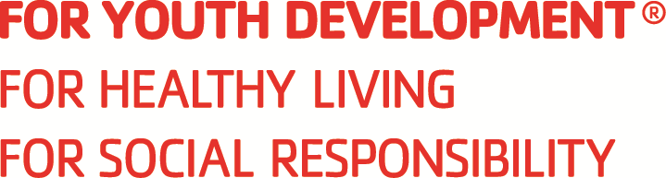

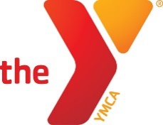

CORONA-NORCO FAMILY YMCA
Job Description & Performance Standards

Position: Lifeguard
Reports To: Program Director

Duties and Responsibilities
- Maintains active surveillance of the pool area.
- Knows and reviews all emergency procedures and responds to emergency situations immediately in accordance with YMCA policies, procedures, and the “safe-in-six” model; completes related reports as required
- Knows, understands, and consistently applies safety rules, policies, and guidelines for the pool and aquatic area
- Maintains accurate records as required by the YMCA and/or the state health department code
- Performs equipment checks and ensures appropriate equipment is available as needed
- Checks the pool for hazardous conditions when arriving
- Performs chemical testing when not guarding, as required, and takes appropriate action
- Identifies and celebrates the successes of members and program participants
- Attends and participates in all staff meetings and in-service training
- Performs other duties as assigned

Mission Advancement
- Models and teaches the Ys values
- Ensures a high level of service with a commitment to changing lives
- Provides volunteers with orientation, training, development, and recognition
- Cultivates relationships to support fund-raising

Collaboration
- Champions inclusion activities, strategies, and initiatives
- Builds relationships to create small communities
- Empathetically listens and communicates for understanding when negotiating and dealing with conflict
- Effectively tailors communications to the appropriate audience
- Provides students with feedback, coaching, guidance and support

Requirements / Skills / Qualifications
- Certifications: Basic life support or professional rescuer CPR/AED, first aid, and emergency oxygen administration or equivalent
- Current YMCA Lifeguard or equivalent (Red Cross Lifeguard)
- Ability to maintain certification-level physical and mental readiness
- Must demonstrate lifeguard skills in accordance with YMCA standards
- Background Check

WORK ENVIRONMENT & PHYSICAL DEMANDS:
- The physical demands described here are representative of those that must be met by an employee to successfully perform the essential functions of this job. Reasonable accommodations may be made to enable individuals with disabilities to perform the essential functions
- Physically perform all skills required of a lifeguard
- Hear noises and distress signals in the aquatic environment, including in the water and anywhere around the zone of responsibility
- Remain alert with no lapses of consciousness
- See and observe all sections of an assigned zone or area of responsibility

