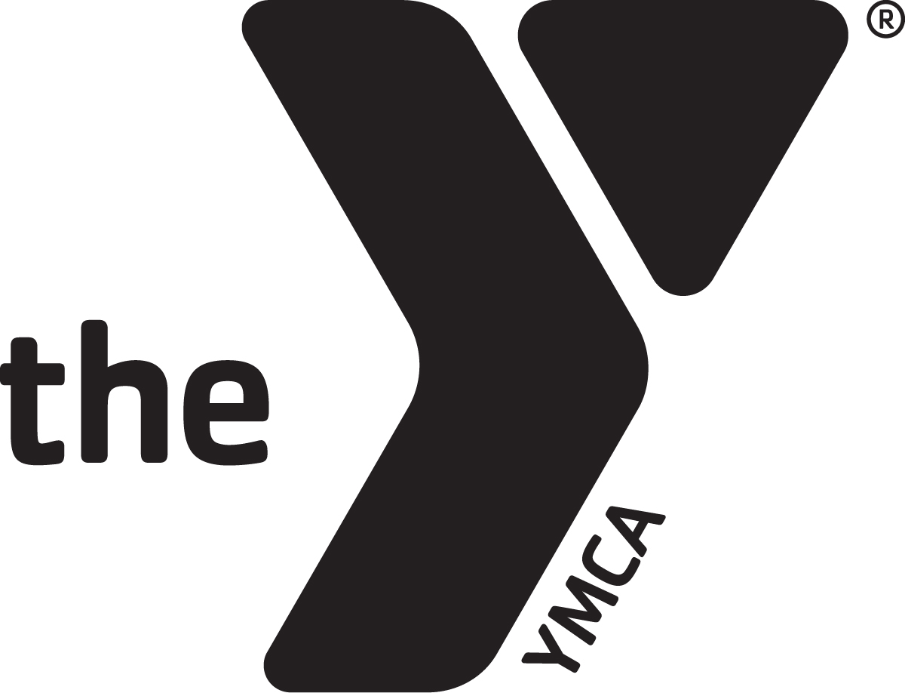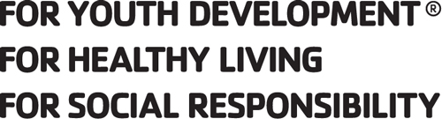
BILLINGS FAMILY YMCA JOB DESCRIPTION
Job Title: Youth Sports Instructor
FLSA Status: Part time, Non-Exempt Revision Date: February 17, 2014
Reports to: Youth Sports Coordinator

POSITION SUMMARY: Under the supervision of the youth sports coordinator, the youth sports instructor will provide instruction of youth sports programs, provide excellent customer service, lead offsite youth sports programs, and will officiate youth sports games. The youth sports instructor implements the YMCA Core Values of Caring, Respect, Responsibility, and Honesty in the program and acts accordingly.

ESSENTIAL FUNCTIONS:
- Leads sports programs by conducting a fun safe and developmentally appropriate program, as directed by the supervisor to accomplish the YMCA mission and goals.
- Officiate youth sports programs according to the general rules of the sport as well as any rules specific to the Billings Family YMCA.
- Know, demonstrate and interpret YMCA philosophy to players, parents, and coaches.
- Report injuries (to League Director), follows safety procedures and guidelines.
- Must demonstrate the ability to control all aspects of the game that you are officiating.
- Builds effective relationships with participants and their parents.
- Maintains onsite and off-site program equipment as assigned by supervisor.
- Possess the ability to work with varying ages and to manage large groups.
- Represents the YMCA at community events as assigned by supervisor.
- Attends and participates in other YMCA program activities, staff meetings, and staff trainings.
- Ability to work flexible hours as program needs arise. Ability to assist in various departments or programs as the need arises.
- Adhere to department S.M.A.R.T. Goals
- Works closely with the league director to address concerns of staff and or members.
CORE COMPETENCIES (ALL STAFF):
CUSTOMER SERVICE
- Always have a friendly, helpful attitude and wear a smile.
- Take initiative to greet and assist all members, potential members, program participants and volunteers in a courteous, professional and friendly manner. Be enthusiastic towards members by learning their names and expressing an interest in their YMCA activities.
- Work daily to develop personal and meaningful relationships with members, volunteers, donors and others. Strive to understand individual’s goals and interests to enrich their YMCA experience by introducing them to new programs, staff, members and volunteer activities.
- Actively listen, reflect and respond to member questions and concerns in a caring manner. When the opportunity presents itself, go above and beyond to resolve the situation immediately.
- Embrace new approaches and discover ideas to create a better member experience.
MISSION ADVANCEMENT
- A willingness to commit to the mission of the YMCA. Demonstrate a desire to serve others and fulfill community needs.
- Is familiar with and able to articulate the mission statement, areas of focus and core values of the YMCA with people of all ages and backgrounds. Models the core values of caring, honesty, respect and responsibility while working and communicating with members, program participants, volunteers and other staff members.
- Be knowledgeable and supportive of the YMCA annual support campaign.
- Be informed about volunteer opportunities.
- Speak enthusiastically on behalf of the YMCA publicly and at given opportunities.
TEAMWORK
- Ability to establish and maintain harmonious relationships with staff members in all departments.
- Seeks every opportunity to encourage, motivate and thank fellow staff members for their work. Completes S.T.A.R. slips to thank and recognize a job well done by others.
- Be knowledgeable about YMCA programs. This includes being familiar with all current program guide information, upcoming events and other special activities.
- Keeps up to date all internal communication.

OPERATIONAL EFFECTIVENESS/SAFETY
- Be dressed in appropriate attire and wear nametag at all times. Consistently perform duties in a safe and conscientious manner.
- Follow and enforce all YMCA procedures and policies, including those related to: personnel guidelines, medical and disciplinary situations, child abuse prevention, safety guidelines, facility access procedures, membership policies and emergencies. Complete Incident Report Forms as required.
- Be knowledgeable of all current Emergency Action Plans and carry out plans as necessary.
- Maintain a clean and safe YMCA. Take initiative to clean up/repair areas. Complete Maintenance Request forms as needed. Report safety issues to the appropriate supervisor.
- Attend and remain current on all mandatory trainings and staff meetings.

QUALIFICATIONS:
- Previous one to two years related experience teaching, officiating (MOA license preferred), and leading children in sports (both is preferred). Experience with youth sports such as playing or coaching. Must have passion for sports.
- Minimum 18 years of age with valid Montana Driver’s License.
- CPR, First Aid, AED certifications required, Child Abuse prevention training within 30 days of hire date.
- Desire and ability to work with children of all ages.
- Must possess strong organizational skills, strong communication skills and is an energetic goal-oriented person.

PHYSICAL DEMANDS:
- Must be in reasonable good physical condition and be able to work extended periods of time on his/her feet. (Moved to Physical Demands section)
- Ability to perform all physical aspect of the position; including walking, standing, bending, kneeling, and lifting.
- The physical ability to supervise, instruct and lead groups of children relating to sports.
- Visual and auditory ability to respond to critical situations and physical ability to act swiftly in an emergency.

This job description may not be all inclusive and employees are expected to perform all other duties as assigned and directed by management. Job descriptions and duties may be modified when deemed appropriate by management.
Employee Name:
Employee Signature: Date:
Directors Signature: Date:

